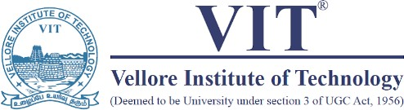

School of Computer Science Engineering and Information Systems

Fall Semester 2026-2027

Department of Computer Applications

PMCA698J – Dissertation -I

Review -1

Date: 14.8.2026
An AI-Driven Blockchain Framework for Continuous Medical Image Integrity Verification, Tamper Forensics, and Self-Recovery

25MCA0261 - GOKUL S
Under the Guidance of
Ramesh P S
Associate Professor Grade.2
SCORE

Guide Signature with date

Internal Examiner -1 Internal Examiner-2
Signature Signature

ABSTRACT:

The rapid digitization of healthcare has created an increased demand for verifiable, reliable, and continuous medical image sharing between hospitals, diagnostic centers, and medical professionals. Medical images such as MRI, CT scans, X-rays, PET, and ultrasounds require confidential, safe, and tamper-evident storage in centralized or distributed systems that remain resistant to privacy breaches, unauthorized access, and limited auditability. This research introduces an AI-Driven Blockchain Framework for Continuous Medical Image Integrity Verification, Tamper Forensics, and Self-Recovery that implements end-to-end medical image security and forensic solution. The framework utilizes 4D Chen hyperchaotic permutation and diffusion with AES-256 encryption to guarantee image confidentiality, integrity, and resistance to tampering. SHA-3 hashing, IPFS decentralized storage, and blockchain technology offer verifiable provenance, storage, and auditability. The framework introduces the concept of Digital Integrity Twin that enables continuous image integrity surveillance. Decentralized Identifiers, Verifiable Credentials, role-based access control, and time-bound permissions allow fine-grained image access and privacy management. The proposed tamper forensic module leverages SRM, Hybrid Swin-UNet, and attention mechanisms for tamper localization and Grad-CAM offers model explanations. A tamper risk score and cybersecurity trust score guide image access and recovery decisions whereby high-risk areas are retrieved from encrypted image repositories with post-recovery verifications and blockchain forensic recordings enhancing medical image security, provenance, and accountability.

Keywords: Blockchain, Medical image security, Digital Integrity Twin, Hyperchaotic encryption, Tamper forensics, Self-Recovery, Swin-UNet, Explainable AI.

[1.] INTRODUCTION:
The digitization and integration of medical images into the healthcare ecosystem has created an increased need for their processing, analysis, storage, and exchange within hospital information systems, diagnostic centers, radiologists, clinicians, etc. The exchange of medical data such as MRI, CT, X-ray, PET, and ultra-sound scans across heterogeneous platforms introduces security and privacy concerns since they often contain patients’ personal details. In this regard, an effective mechanism needs to be designed to allow secure and private sharing of medical images while providing constant integrity verification, localization of tampered regions, and ensuring trustworthiness of medical-image sharing across hospitals, diagnostic centers, and radiologists.

Existing centralized approaches to medical image sharing suffer from a lack of integrity guarantees, insufficient localization of tampered areas, and poor traceability of modifications. Encrypting medical images prevents outsiders from accessing the data, but conventional encryption lacks built-in integrity verification, localization of tampered regions, and self-recovery features. Likewise, hashing algorithms can detect manipulation by comparing input and output hashes, but they cannot identify the tampered regions unless the hash values are incorporated into the image, which compromises confidentiality. AI-based localization solutions can identify tampered areas, but they must be initially trained on a reliable data set that incorporates integrity proofs. These considerations inspired the design of the proposed 4D chen hyperchaotic encryption, AES-256 encryption, SHA-3, IPFS decentralized storage, and blockchain-based integrity verification framework with hybrid swin-UNet and grad-cam-based tamper forensic analysis. The design contains a digital-twin-driven integrity checker to localize tampered regions and a self-healing algorithm based on the Regions of Interest (ROI) to recover unaltered areas of the medical images. Additionally, the system utilizes Trust Score to ensure cybersecurity trustworthiness, ROI-based tamper risk score, Integrity Forensic Score (IFS), and explainable-AI to provide a reliable and explainable medical image sharing framework that prevents unauthorized access, guarantees integrity, provides localization of tampered areas, and ensures end-to-end security of medical-image sharing.

[2.] PROBLEM STATEMENT:
The growth of digital healthcare platforms has increased the need for medical image sharing across hospitals, diagnostic centers, radiologists, and healthcare professionals. At the same time, traditional centralized medical-image systems encounter confidentiality, integrity, access control, provenance, and auditability challenges. Medical images can be subject to unauthorized disclosure, and their contents may be manipulated, impacting diagnosis and treatment outcomes. Existing encryption approaches mainly focus on confidentiality but provide limited integrity checks and do not indicate where modifications occur. Hash-based integrity checking mechanisms can identify whether an image has been altered but do not show precisely where the changes are. Blockchain technology enhances integrity, provenance, and auditability but cannot indicate where image tampering occurs. Likewise, AI-based forensic approaches can locate image alterations but offer limited end-to-end security, access control, and audit trails.

The medical image security framework should offer post-processing integrity verification, access control, detection and localization of tampering, explainable AI, risk assessment, and recovery of trusted image content. The proposed project will address these requirements by employing post-processing integrity verification using blockchain technology, adaptive encryption, Digital Integrity Twin, and AI-based tamper localization and forensics. The framework will also implement risk-adaptive access control and self-recovery mechanisms.

[3.] OBJECTIVES:
The main objective of this project is to design an AI-Driven Blockchain Framework for Continuous Medical Image Integrity Verification, Tamper Forensics, and Self-Recovery that can provide secure, traceable, and resilient medical image sharing.

1. To ensure medical image confidentiality using 4D Chen hyperchaotic permutation and diffusion followed by AES-256 encryption
2. To guarantee image integrity throughout its lifecycle using SHA-3 hashing and a Digital Integrity Twin for maintaining a cryptographic baseline
3. To enable secure storage and provenance of medical images using IPFS for encrypted image storage and blockchain for integrity-related information storage
4. To achieve secure access and identity management using Decentralized Identifiers, Verifiable Credentials, Role-Based Access Control, and time-bound permissions
5. To perform image tamper detection and localization using SRM-based forensic analysis, Hybrid Swin-UNet, and attention mechanisms
6. To provide explainable AI-based tamper forensic analysis using Grad-CAM-based visualization of activation regions
7. To assess tampering risk and image trustworthiness using a tamper risk score and cybersecurity trust score
8. To implement risk-adaptive access control to images and enable image quarantine when needed
9. To realize region-level image self-recovery by retrieving regions from encrypted archives and reconstructing the image

10. To perform post-recovery integrity verification and tamper forensic recording using SHA-3 and blockchain-based audit trail

[4.] SCOPE OF THE PROJECT:
The scope of this project covers the development of a secure, continuously verifiable, and intelligent medical image-sharing framework that combines cryptography, blockchain, decentralized storage, access control, and AI-based forensic analysis.
- Secure Medical Image Management
The framework supports medical images such as MRI, CT, X-ray, PET, and Ultrasound, with confidentiality protection using 4D Chen hyperchaotic encryption and AES-256.
- Continuous Integrity Verification
SHA-3 hashing and a Digital Integrity Twin are used to establish and continuously verify the trusted state of medical images.
- Decentralized Storage and Provenance
Encrypted images can be maintained in IPFS/decentralized storage, while blockchain stores integrity-related hashes, metadata, and audit information.
- Identity and Access Management
The system covers DIDs, Verifiable Credentials, RBAC, and time-bound permissions for controlled medical-image sharing.
- AI-Based Tamper Forensics
SRM, Hybrid Swin-UNet, and attention mechanisms are used to identify and localize suspicious or manipulated regions.
- Explainable AI
Grad-CAM provides visual explanations of the regions influencing AI-based forensic predictions.
- Risk and Trust Assessment
Tamper risk and cybersecurity trust scores can be used to support risk-adaptive access decisions.
- Self-Recovery and Verification
The framework covers region-level recovery from trusted encrypted image archives, followed by post-recovery integrity verification.
- Forensic Auditing
Security events, tampering incidents, recovery actions, and relevant integrity information can be recorded on the blockchain to provide a traceable forensic history.
- ] PROPOSED SYSTEM:
The proposed system is an AI-Driven Blockchain Framework for Continuous Medical Image Integrity Verification, Tamper Forensics, and Self-Recovery, designed to provide secure and reliable medical image sharing among hospitals, diagnostic centers, and healthcare professionals. The framework first authenticates users through Decentralized Identifiers (DIDs), Verifiable Credentials, and Role-Based Access Control (RBAC) with time-bound permissions. Uploaded medical images are protected using 4D Chen hyperchaotic permutation and diffusion combined with AES-256 encryption, ensuring confidentiality during storage and sharing. A SHA-3 cryptographic hash is generated to establish image integrity, while a Digital Integrity Twin maintains a trusted baseline for continuous verification. The encrypted image is stored in IPFS/decentralized storage, whereas hash values, provenance information, and audit records are maintained on the blockchain. During image retrieval or sharing, the current image integrity is compared against the trusted baseline. If a mismatch is detected, the framework activates AI-based tamper forensics using SRM, Hybrid Swin-UNet, and attention mechanisms to identify and localize suspicious regions. Grad-CAM provides visual explanations for the AI decision. The system then calculates tamper risk and cybersecurity trust scores to support risk-adaptive access decisions. For high-risk modifications, the affected regions can be recovered from trusted encrypted image archives, followed by post-recovery integrity verification and blockchain-based forensic recording. Thus, the proposed system provides a continuous security lifecycle covering protection, verification, access control, tamper localization, explanation, risk assessment, self-recovery, and forensic auditing.

[5.] LITERATURE SURVEY:

S.NO | TITLE | MERITS | DEMERITS
1 | Zero-Trust Medical Image Sharing: A Secure and Decentralized Approach Using Blockchain and the IPFS | This paper proposes a zero-trust architecture combining blockchain and IPFS for secure medical-image sharing. It improves decentralization, data integrity, and access security while reducing dependence on centralized storage. | The framework mainly concentrates on secure sharing and decentralized storage. It does not provide an advanced AI-based tamper localization mechanism to identify the exact manipulated region.
2 | Decentralized Medical Image Sharing: A Blockchain Based Approach with Subject Sensitive Hashing for Enhanced Privacy and Integrity | The framework combines JPEG compression, feature extraction, encryption, IPFS, blockchain, and subject-sensitive hashing. Smart contracts are used to validate image-access requests, and the reported average correctness is 98% | The method focuses mainly on feature/hash-based integrity verification. It does not provide detailed AI forensic localization and explainability for manipulated regions.
3 | Enhanced Security for Medical Images Using a New 5D Hyper Chaotic Map and Deep Learning Based Segmentation | A new 5D hyperchaotic map is combined with a customized U-Net for secure medical-image encryption. The method reports strong statistical-security results, including high entropy and low correlatio | The approach mainly addresses image encryption. It does not integrate blockchain-based immutable auditing, decentralized identity, or smart access control into the complete sharing workflow.
4 | An Encryption Algorithm for Multiple Medical Images Based on a Novel Chaotic System and an Odd-Even Separation Strategy | The paper proposes a novel chaotic system for encrypting multiple medical images and focuses on protecting sensitive medical information from unauthorized disclosure. | The work concentrates on cryptographic protection and does not provide an integrated blockchain framework or AI-based tamper localization.
5 | Medical Image Encryption Based on Josephus Traversing and Hyperchaotic Lorenz System | The method combines Josephus scrambling, Arnold-map scrambling, hyperchaotic Lorenz sequences, and diffusion to protect medical images. It demonstrates resistance against common attacks and considers image damage during telemedicine. | The system focuses mainly on encryption and robustness. It does not provide blockchain-supported integrity records or intelligent localization of manipulated regions.
6 | DICOM Compatible, 3D Multimodality Image Encryption Using Hyperchaotic Signal | The proposed method supports multiple medical-image modalities including MRI, CT, X-ray, and ultrasound. Hyperchaotic signals and multi-level diffusion are used to increase security, with an additional authentication mechanism. | The primary contribution is encryption and authentication. It does not combine encryption with blockchain auditability and AI-based forensic tamper localization.
7 | A High-Security Chaotic Encryption Model for Biomedical Image Protection | The paper proposes a chaotic/hyperchaotic encryption approach based on an R3 model involving rotation, rescaling, and randomization. It aims to reduce pixel correlation and improve protection of biomedical images. | The method primarily focuses on confidentiality through encryption and does not address decentralized access control, blockchain verification, or AI-based tamper localization.
8 | Novel Aspects of Secure Medical Image Encryption Using Block-Chain and Transformer-Based Deep Learning Model | This work combines blockchain technology with a Transformer-based deep-learning model to improve medical-image security, privacy, and integrity. | Although blockchain and deep learning are integrated, the approach does not fully address explainable tamper-region localization, decentralized identity, and time-limited access control as a unified framework.
9. | Building an IPFS and Blockchain-Based Decentralized Storage Model for Medical Imaging | The proposed framework uses IPFS and blockchain to reduce dependence on third-party centralized storage and provide a decentralized model for medical-image sharing. | The work primarily addresses decentralized storage and sharing. Advanced encryption, AI-based tamper detection, and explainable localization are not comprehensively integrated.
10 | Blockchain-Enabled Security for Medical Image Transmission: Prescription Data Hiding and Multi-Secret Sharing-Based Encryption | This paper produces an automated system which predicts the heart disease accurately based on the symptoms according to gender/age and domain knowledge of experts in the field at the lowest cost. | Classification via clustering achieves poor compared to other two methods. Author intends to extend the work for predicting the intensity of the disease using fuzzy methods.
11 | Swin-Unet: Unet-Like Pure Transformer for Medical Image Segmentation | Swin-UNet introduces a pure Transformer-based U-shaped architecture using shifted-window attention to capture both local and global features. It demonstrates strong performance in medical-image segmentation tasks. | The original model is designed for medical-image segmentation, not image-forensic tamper localization. It also does not address blockchain, encryption, or secure image sharing.
12 | TransForensics: Image Forgery Localization with Dense Self-Attention | TransForensics applies Transformer-based dense self-attention and correction modules for image-forgery localization. It can model global relationships and produce high-quality forgery masks | It is a general image-forensics approach rather than a complete medical-image security framework. It does not provide blockchain-based integrity evidence or secure medical-image access management.
13 | TBFormer: Two-Branch Transformer for Image Forgery Localization | The patient and the doctor provided the project's input information. Heart illness is then analyzed using various AI algorithms using the doctor's inputs. The results are now compared to those of other models that have been used in the same area and are determined to be superior. | Accuracy cannot be guaranteed by a computerized system alone, and warehouse data is only as reliable as the data input that produce
14 | Progressive Feedback-Enhanced Transformer for Image Forgery Localization | The ProFact model performs coarse-to-fine forgery localization by feeding localization information back into Transformer layers. It improves robustness and generalization across multiple forensic datasets. | The method is focused on general image-forgery localization. It does not connect the detected manipulation with blockchain-based integrity verification or medical-image access auditing.
15 | Quantum-Inspired Post-Quantum Secure DCT Watermarking for Tamper Detection and Localization in Medical Images | This recent work proposes medical-image watermarking using SHA3-256-based keys, DCT embedding, tamper detection, and localization. It reports more than 80% tamper localization with high image quality and classification accuracy. | The approach is primarily watermark-based and does not provide a complete combination of blockchain-based sharing, smart access control, decentralized identity, hyperchaotic encryption, and explainable AI.

[6.] FINDINGS IN LITERATURE SURVEY:
The literature survey shows that existing research has addressed different aspects of medical image security, including hyperchaotic encryption, blockchain-based integrity verification, decentralized storage, access control, and AI-based tamper localization. However, these approaches are generally focused on individual security requirements or partial combinations of technologies.
- Medical Image Encryption: Hyperchaotic and chaotic encryption techniques provide strong confidentiality and improve resistance against unauthorized disclosure and common attacks.
- Blockchain and IPFS: Blockchain and IPFS improve decentralized storage, integrity verification, provenance, traceability, and auditability of medical images.
- Access Control: Smart contracts, role-based permissions, decentralized identity, and controlled access mechanisms improve secure medical-image sharing.
- AI-Based Forensics: Transformer-based models such as Swin-UNet and other forensic approaches demonstrate the ability to detect and localize manipulated regions in images.
- Explainability: Techniques such as attention mechanisms and Grad-CAM can improve the interpretability of AI-based forensic decisions.
- Limitations of Existing Approaches: Most existing approaches do not provide a complete lifecycle combining continuous integrity verification, Digital Integrity Twin, tamper-risk assessment, cybersecurity trust scoring, risk-adaptive access control, forensic evidence recording, and self-recovery.

- ] METHEDOLOGY:
The proposed methodology follows an end-to-end secure medical-image lifecycle that integrates cryptographic protection, decentralized storage, blockchain verification, intelligent access control, AI-based tamper forensics, risk assessment, and self-recovery. The methodology is designed to move beyond one-time integrity checking by continuously monitoring the image throughout its storage, sharing, retrieval, and recovery stages.

7.1 Medical Image Acquisition and Preprocessing
Medical images such as MRI, CT, X-ray, PET, and Ultrasound are collected from the selected medical-image dataset. The images are preprocessed into a suitable format and resolution for encryption and AI-based forensic analysis. Relevant image metadata is maintained separately to support provenance and integrity verification.

7.2 Identity and Access Management
Before uploading or accessing an image, the healthcare user is authenticated using Decentralized Identifiers (DIDs) and Verifiable Credentials. Role-Based Access Control (RBAC) determines the permissions associated with doctors, radiologists, administrators, or other authorized users. Time-bound permissions are used to control the duration of image access.

7.3 Adaptive Medical Image Encryption
The medical image is protected using 4D Chen hyperchaotic permutation and diffusion, which generates complex chaotic sequences for pixel scrambling and diffusion. The resulting image is further protected using AES-256 encryption to provide an additional standardized cryptographic security layer.

7.4 Integrity Fingerprint and Digital Integrity Twin
After encryption, a unique SHA-3 hash is generated as the image's cryptographic fingerprint. A Digital Integrity Twin is then created as a trusted baseline containing relevant integrity information such as image hash, metadata information, region-level integrity information, and associated provenance data. This baseline is used for continuous integrity verification.

7.5 Decentralized Storage and Blockchain Registration
The encrypted medical image is stored in IPFS/decentralized storage, while the corresponding hash, content identifier, metadata, and provenance information are recorded on the blockchain. Blockchain provides an immutable and auditable record without storing the large medical image directly on-chain.

7.6 Continuous Integrity Verification
Whenever an image is accessed, transferred, or retrieved, its current integrity information is compared with the trusted Digital Integrity Twin and blockchain records. If the values match, the image is considered integrity-verified. If a mismatch occurs, the system identifies the image as potentially compromised and initiates the AI-based forensic analysis process.

7.7 AI-Based Tamper Forensics
For potentially manipulated images, SRM-based forensic feature extraction, Hybrid Swin-UNet, and attention mechanisms are used to identify and localize suspicious regions. The output is a tamper mask indicating the regions that require further investigation.

7.8 Explainable AI Analysis
Grad-CAM is applied to provide a visual explanation of the AI model's decision. The generated heatmap highlights the image regions that contributed significantly to the forensic prediction, improving interpretability of the tamper-localization process.

7.9 Tamper Risk and Cybersecurity Trust Assessment
The localized tampering information is combined with factors such as AI confidence, tampered-region proportion, integrity status, and provenance status to calculate a tamper risk score. A separate cybersecurity trust score represents the overall integrity and security status of the image.

7.10 Risk-Adaptive Access Control
The calculated risk and trust scores are used to determine the appropriate security response. Low-risk images can be accessed normally, medium-risk images can require additional verification, and high-risk images can be restricted or quarantined until further analysis or recovery is completed.

7.11 Region-Level Self-Recovery
For high-risk tampering, the affected regions are retrieved from a trusted encrypted image version stored in decentralized storage. The verified original regions are used to reconstruct the affected image. This provides a controlled recovery mechanism rather than simply discarding the compromised image.

7.12 Post-Recovery Verification
After recovery, the reconstructed image is subjected to SHA-3 integrity verification and comparison with the Digital Integrity Twin. Only after successful verification is the recovered image considered suitable for authorized access.

7.13 Forensic Evidence and Blockchain Audit
The complete security event—including tamper detection, localized region, risk level, recovery action, verification status, timestamp, and forensic fingerprint—is recorded as an auditable blockchain event. This creates an immutable history of the image's security lifecycle.

[9.] SOFTWARE REQUIREMENTS:
[9.l] Functional Requirements
The proposed AI-Driven Blockchain Framework for Continuous Medical Image Integrity Verification, Tamper Forensics, and Self-Recovery shall provide the following functional requirements:
- User Registration and Authentication
The system shall allow authorized healthcare users to register and securely authenticate before accessing medical images.
- Decentralized Identity Management
The system shall support DIDs and Verifiable Credentials for identity verification and trusted user identification.
- Medical Image Upload
Authorized users shall be able to upload medical images such as MRI, CT, X-ray, PET, and Ultrasound for secure processing.
- Medical Image Encryption
The system shall protect uploaded images using 4D Chen hyperchaotic permutation and diffusion followed by AES-256 encryption.
- SHA-3 Hash Generation
The system shall generate a unique SHA-3 cryptographic fingerprint for each protected medical image.
- Digital Integrity Twin Creation
The system shall create and maintain a Digital Integrity Twin containing trusted integrity and provenance information for continuous verification.
- Decentralized Image Storage
The system shall store encrypted medical images in IPFS/decentralized storage and maintain their content identifiers.
- Blockchain Registration
The system shall record relevant image hashes, storage references, provenance information, and security events on the blockchain.
- Role-Based Access Control
The system shall provide RBAC-based permissions for controlling access according to user roles.
- Time-Bound Access Management
The system shall support granting, monitoring, and revoking image access based on predefined time limits.
- Continuous Integrity Verification
The system shall compare the current image integrity information with the Digital Integrity Twin and blockchain records whenever the image is accessed or retrieved.
- Tamper Detection and Localization
When an integrity mismatch is detected, the system shall initiate AI-based forensic analysis using SRM, Hybrid Swin-UNet, and attention mechanisms to identify suspicious regions.
- Explainable AI Analysis
The system shall use Grad-CAM to generate visual explanations of the regions influencing the AI-based forensic decision.
- Tamper Risk Assessment
The system shall calculate a tamper risk score based on the detected forensic information and integrity status.
- Cybersecurity Trust Assessment
The system shall generate a cybersecurity trust score to represent the overall security and integrity status of the medical image.
- Risk-Adaptive Access Control
The system shall dynamically allow, restrict, require additional verification, or quarantine image access based on the calculated risk and trust levels.
- Region-Level Self-Recovery
For significant tampering, the system shall retrieve trusted image regions from encrypted decentralized storage and reconstruct the affected image.
- Post-Recovery Verification
The system shall re-calculate and verify the SHA-3 integrity information after recovery before restoring normal access.
- Forensic Evidence Generation
The system shall generate a forensic record containing relevant information such as tampered region, risk level, AI confidence, recovery status, and timestamp.
- Blockchain-Based Forensic Audit
The system shall record tampering, access, recovery, and verification events on the blockchain to provide an immutable and traceable security history.
- Security Alerts and Reporting
The system shall generate alerts for suspicious or high-risk image activity and provide security reports for authorized administrators.

[9.2] Non Functional Requirements
The proposed system shall satisfy the following non-functional requirements to ensure that the medical-image security framework is reliable, secure, efficient, maintainable, and suitable for future healthcare integration. The major quality attributes identified for the project include security, confidentiality, integrity, reliability, performance, scalability, availability, fault tolerance, privacy, usability, maintainability, and interoperability.
- Security
The system shall provide strong protection against unauthorized access, data manipulation, and security threats through encryption, blockchain, authentication, and access-control mechanisms.
- Confidentiality
Sensitive patient and medical-image information shall be protected from unauthorized disclosure using 4D Chen hyperchaotic encryption and AES-256.
- Integrity
The system shall maintain the integrity of medical images through SHA-3 hashing, Digital Integrity Twin verification, and blockchain-based records.
- Reliability
The system shall provide consistent and dependable image verification, tamper detection, recovery, and access-control operations.
- Performance
Encryption, hash generation, image verification, AI-based forensic analysis, and recovery should be performed within reasonable processing time.
- Scalability
The framework should support an increasing number of users, medical images, access requests, and blockchain transactions without significant degradation in performance.
- Availability
Authorized users should be able to access valid medical images and required system services whenever they are available and permitted.
- Fault Tolerance
The system should handle storage, verification, or communication failures without causing permanent loss of trusted medical-image information.
- Privacy
Patient-sensitive information shall be protected throughout image storage, processing, transmission, and sharing, with access limited to authorized users.
- Usability
The system should provide a simple and understandable interface for uploading images, requesting access, viewing integrity status, reviewing forensic results, and monitoring security events.
- Maintainability
The system should use modular components so that encryption, blockchain, AI models, access control, and recovery mechanisms can be independently updated or maintained.
- Interoperability
The framework should be designed to support integration with existing healthcare imaging workflows and future systems such as PACS and multi-hospital healthcare networks.
- Auditability and Traceability
Security, access, tampering, recovery, and verification events should be traceable through immutable blockchain-backed records.
- Explainability
AI-based forensic decisions should provide understandable visual evidence through Grad-CAM, helping authorized users interpret the detected suspicious regions.
- Data Recovery and Resilience
The system should support trusted region-level recovery and post-recovery verification to maintain the availability and integrity of medical images after detected tampering.

[10.] SYSTEM ARCHITECTURE:
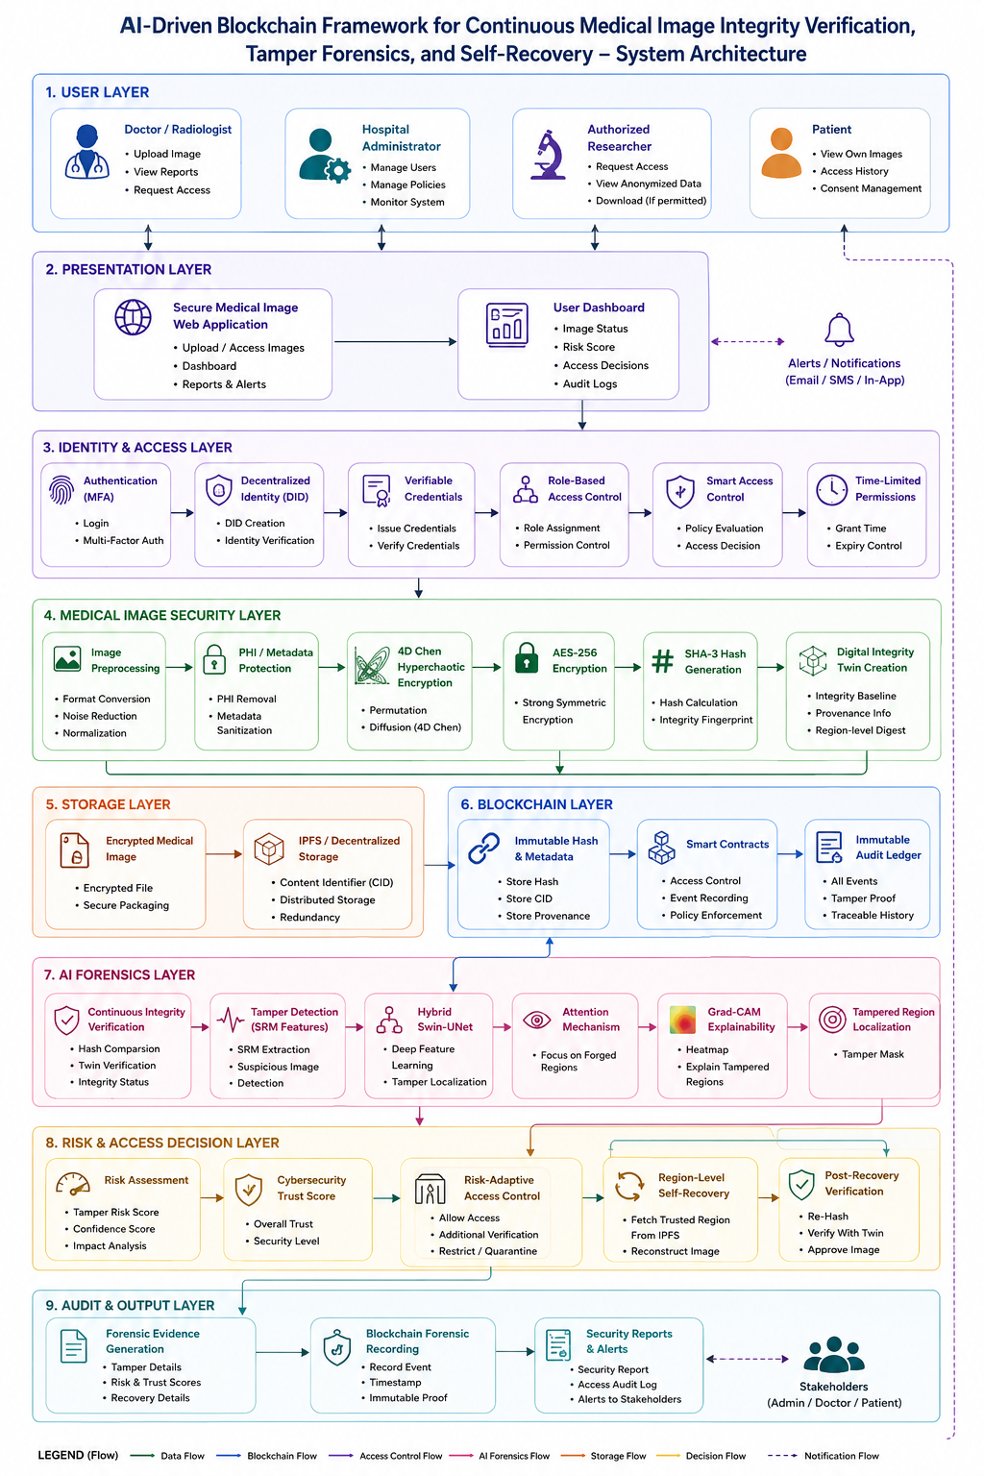
Fig. 10.1 System Architecture

- UML DIAGRAMS:

Class Diagram :
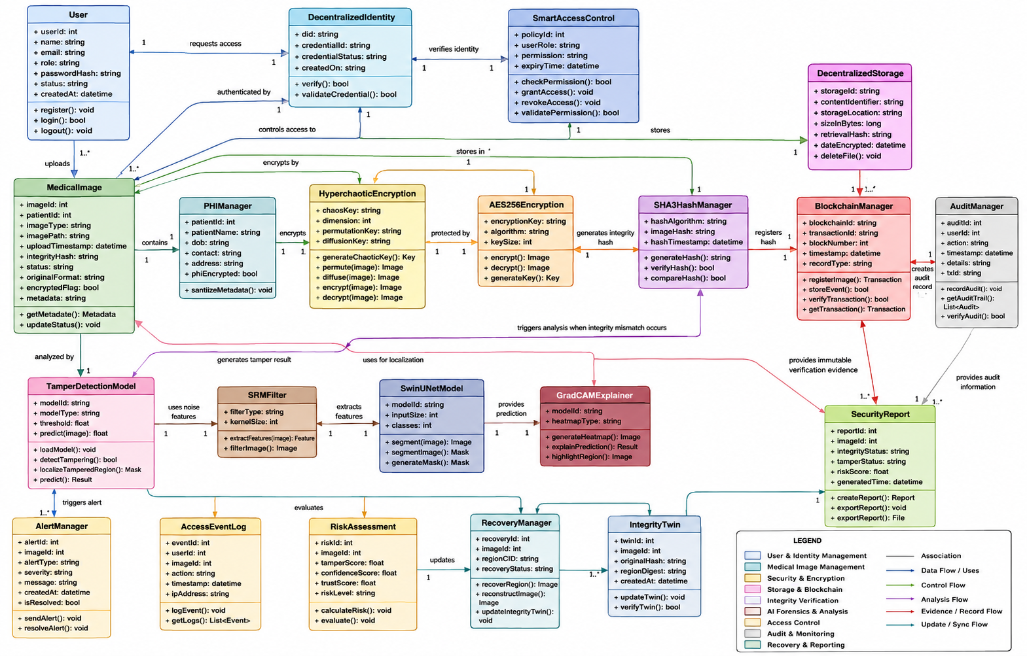

Use Case :
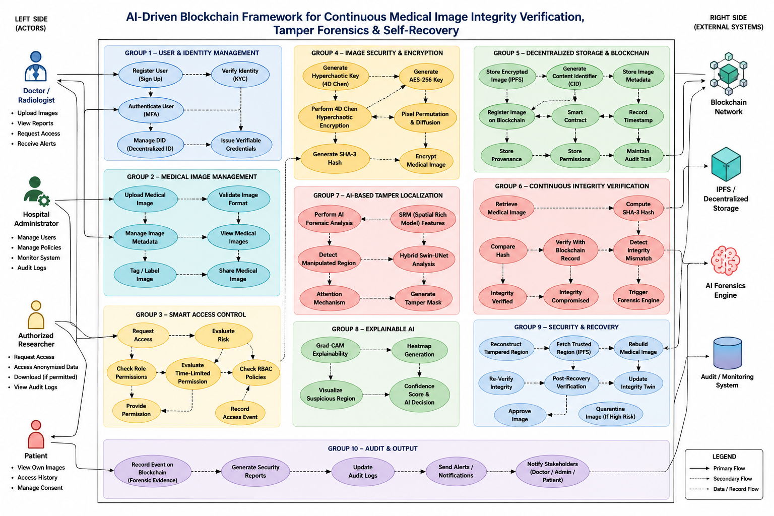

[11]SUMMARY:

The proposed project presents an AI-Driven Blockchain Framework for Continuous Medical Image Integrity Verification, Tamper Forensics, and Self-Recovery to provide secure and reliable medical image management. The framework combines 4D Chen hyperchaotic encryption, AES-256, SHA-3 hashing, IPFS, blockchain, decentralized identity, and smart access control to protect medical images and maintain their provenance. A Digital Integrity Twin enables continuous integrity verification throughout the image lifecycle. When tampering is detected, SRM-based forensic analysis, Hybrid Swin-UNet, attention mechanisms, and Grad-CAM are used to detect, localize, and explain suspicious regions. Tamper risk and cybersecurity trust scores support risk-adaptive access decisions. High-risk images can undergo region-level self-recovery from trusted encrypted storage, followed by post-recovery verification. Finally, tampering, recovery, access, and verification events are recorded on the blockchain to provide an immutable forensic audit trail. Overall, the framework aims to transform medical image security from simple encryption and one-time verification into a continuous, explainable, risk-aware, self-recovering, and auditable security lifecycle.

REFERENCES:

[1] Y. Arafat, A. S. M. Siam, M. M. Chowdhury, M. M. Hasan, S. H. Jobayer, S. Shatabda, S. Islam, and S. Mukta, “Decentralized Medical Image Sharing: A Blockchain Based Approach with Subject Sensitive Hashing for Enhanced Privacy and Integrity,” IET Blockchain, vol. 5, no. 1, e70009, 2025. DOI: 10.1049/blc2.70009.
[2] G. Archana, R. Goyal, and K. M. V. M. Kumar, “Blockchain-Driven Optimized Chaotic Encryption Scheme for Medical Image Transmission in IoT-Edge Environment,” International Journal of Computational Intelligence Systems, vol. 18, 2025.
[3] R. Amdouni, M. Madani, M. A. Hajjaji, E. B. Bourennane, and M. Atri, “Secure Medical Image Transmission Using Chaotic Encryption and Blockchain-Based Integrity Verification,” Computers, Materials & Continua, vol. 84, no. 3, pp. 5527–5553, 2025. DOI: 10.32604/cmc.2025.065356.
[4] U. Shahid, S. Kanwal, M. Bano, S. Inam, M. E. M. Abdalla, and Z. A. Shaikh, “Blockchain Driven Medical Image Encryption Employing Chaotic Tent Map in Cloud Computing,” Scientific Reports, vol. 15, 6236, 2025. DOI: 10.1038/s41598-025-90502-5.
[5] S. Afzal, M. U. Bokhari, I. Khan, M. A. Siddiqui, A. Ahmad, and M. Aijaz, “A Hybrid Encryption Model for Medical Image Security in IoT Healthcare,” Discover Computing, vol. 28, 321, 2025. DOI: 10.1007/s10791-025-09876-9.
[6] S. R. Mallick, S. Sobhanayak, and R. K. Lenkar, “Secure and Trusted Data Sharing in Smart Healthcare Using Blockchain and IoT Integration,” Discover Internet of Things, vol. 5, 90, 2025. DOI: 10.1007/s43926-025-00195-5.
[7] A. Zhao and H. Tian, “Secure Sharing of Electronic Medical Records Based on Blockchain and Searchable Encryption,” Electronics, vol. 14, no. 13, 2679, 2025. DOI: 10.3390/electronics14132679.
[8] S. D. Mahmood, F. Drira, H. F. Mahdi, and A. M. Alimi, “Secure Medical Image Sharing: Technologies, Watermarking Insights, and Open Issues,” IEEE Access, 2025.
[9] M. Li, A. R. Harish, C. Yu, Y. Yu, R. R. Zhong, and G. Q. Huang, “Blockchain-Based Medical Data Asset Sharing Framework for Healthcare 4.0,” IEEE Transactions on Industrial Informatics, vol. 21, no. 4, pp. 2779–2788, 2025. DOI: 10.1109/TII.2024.3488795.
[10] Z. Man and S. Li, “Data Protection and Efficient Transmission for Smart Healthcare: An RDHEI Approach Based on LZW Compression and Composite Key Mechanism,” Expert Systems with Applications, vol. 296, 129040, 2026. DOI: 10.1016/j.eswa.2025.129040.
[11] S. Jagadeesh, A. K. Parida, and K. Meenakshi, “Tamper Detection, Localization and Self-Recovery Using Slant Transform with DNA Encoding for Medical Images,” Results in Engineering, vol. 27, 105907, 2025. DOI: 10.1016/j.rineng.2025.105907.
[12] R. Bouarroudj, F. Souami, F. Z. Bellala, N. Zerrouki, F. Harrou, and Y. Sun, “Secure and Reversible Fragile Watermarking for Accurate Authentication and Tamper Localization in Medical Images,” Computers & Electrical Engineering, vol. 123, 110072, 2025. DOI: 10.1016/j.compeleceng.2025.110072.
[13] R. Shinde, S. Patil, K. Kotecha, and S. Mishra, “Ensuring the Integrity of AI Models: A Blockchain-Based Approach for Protecting Medical Imaging Training Data,” Scientific Reports, vol. 16, 13989, 2026. DOI: 10.1038/s41598-026-44040-3.
[14] S. J. Jagadeesh, A. K. Parida, and M. Kollati, “SMARTMed: Semi-Fragile Dual Watermarking with Deep Tamper Detection and Adversarial DNN Fingerprinting for Secure Medical Image Transmission,” Scientific Reports, 2026. DOI: 10.1038/s41598-026-60362-8.
[15] S. A. I. Alfarozi and H. A. Nugroho, “Reversible Watermarking for Medical Images Using ROI-Based Tamper Localization and Recovery,” Journal of the Franklin Institute, vol. 15, 100545, 2026. DOI: 10.1016/j.fraope.2026.100545.

